**Ideation Phase**

**Empathize & Discover**

|  |  |
| --- | --- |
| Date | 31 October 2025 |
| Team ID | NM2025TMID05966 |
| Project Name | Streamline Ticket Assignment for Efficient Operations |
| Maximum Marks | 4 Marks |

**Empathy Map Canvas:**

An empathy map is a simple, easy-to-digest visual that captures knowledge about a user’s behaviours and attitudes. It helps teams better understand their users. Creating an effective solution requires understanding the true problem and the person who is experiencing it.  
The exercise of creating the map helps participants consider things from the user’s perspective along with their goals and challenges. In this project, the empathy map focuses on understanding the challenges faced by **IT helpdesk agents and support managers** in managing ticket assignment. Currently, most ticket systems rely on manual processes that cause delays, confusion, and an unequal workload among employees. By empathizing with users, we can identify pain points and design an automated ticket assignment system that streamlines workflow, enhances efficiency, and ensures timely responses.

**Example:**

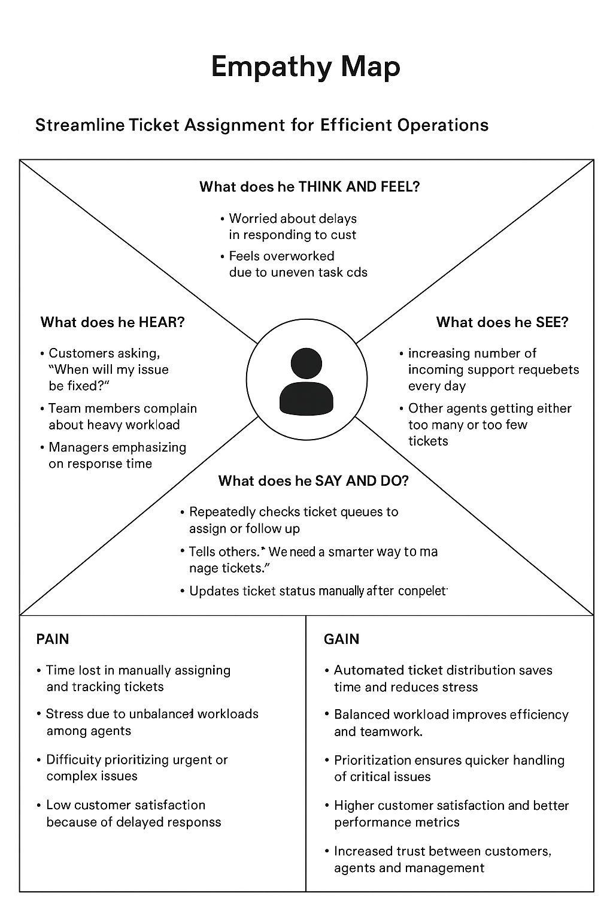

Reference: <https://www.mural.co/templates/empathy-map-canvas>

**Example:** Streamline Ticket Assignment for Efficient Operations

